https://kubevirt.io/user-guide/architecture/

Deploying a completely new Virtual Machine or importing an existing workload (from VMware or Red Hat Virtualization) onto OpenShift relies on KubeVirt technology.

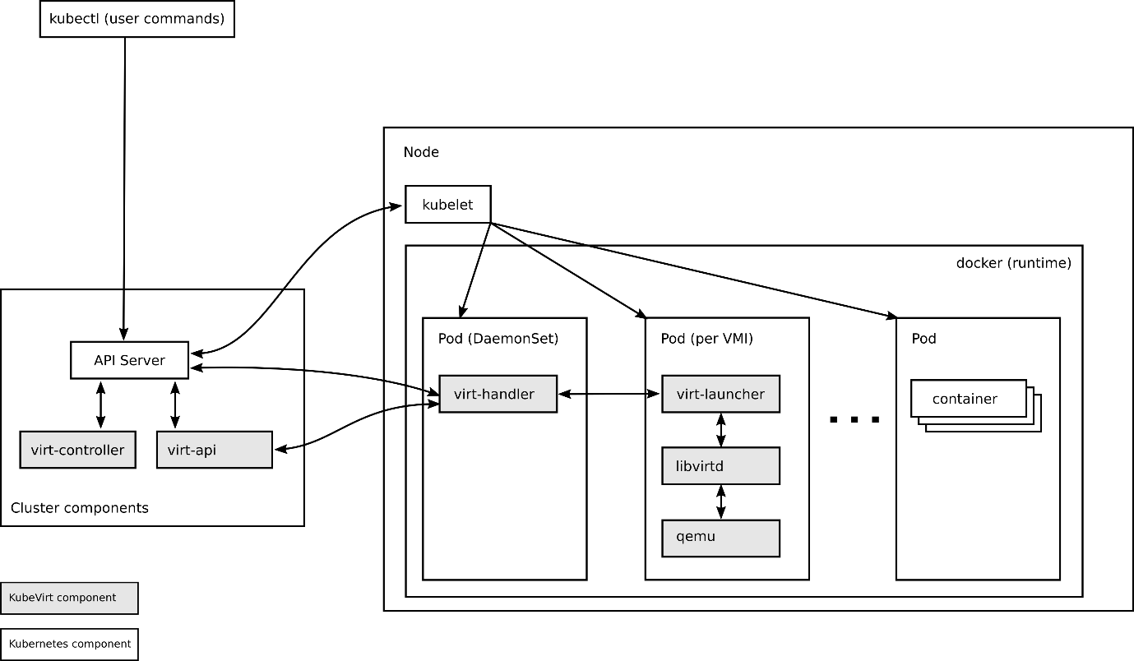

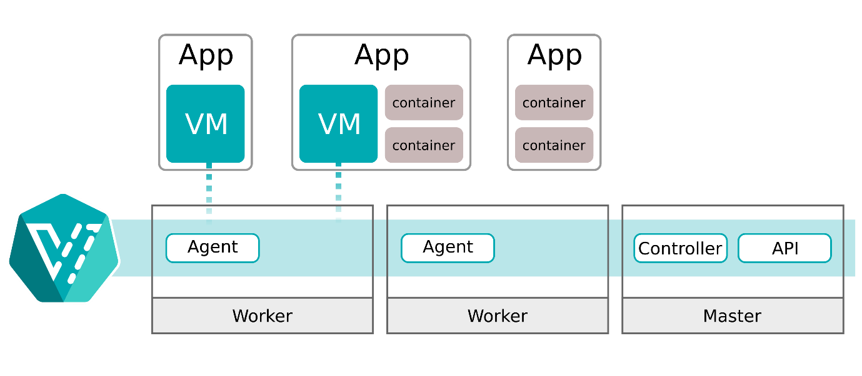

Under the hood, OpenShift runs your VM inside a Kubernetes pod (using a lightweight QEMU/KVM hypervisor instance). The technical workflow varies slightly depending on whether you are building a fresh VM or importing a legacy one.
Workflow A: Deploying a New VM (Greenfield)
When creating a new VM, OpenShift leverages the Containerized Data Importer (CDI) to pull an OS image, write it to persistent storage, and boot the instance.
[OS Image Source (URL/Registry)]
│
▼ (CDI Operator handles transfer)
[DataVolume / PVC] ───► Bound to Storage Class (e.g., ODF)
│
▼ (KubeVirt Orchestration)
[VirtualMachine Pod] ───► Starts QEMU/KVM inside container
Step 1: Storage Provisioning (DataVolume)
You trigger a VM creation via the UI Catalog or a YAML file. OpenShift creates a custom resource called a DataVolume (an abstraction over a standard PersistentVolumeClaim).
- The CDI controller spins up a temporary helper pod (cdi-importer).
- This helper pod streams the OS installation source (from an ISO URL, container registry, or explicit upload) and writes it directly onto the underlying storage provider (like OpenShift Data Foundation).
Step 2: Resource Allocation and Scheduling
Once the DataVolume status turns to Succeeded, the VirtualMachine (VM) controller interprets your defined compute profile:
- It maps the requested vCPUs and RAM to standard Kubernetes limits and requests.
- The Kubernetes Scheduler evaluates the cluster to find a bare-metal worker node with adequate resources and proper CPU capabilities.
Step 3: Pod Execution (virt-launcher)
The scheduler assigns the workload to a node. KubeVirt then creates a pod running a binary called virt-launcher.
- The virt-launcher pod acts as a secure boundary and triggers a local QEMU/KVM instance inside the container.
- It binds the DataVolume as a standard block device block file (/dev/vda) to the hypervisor process.
Step 4: Networking and Boot
- The NetworkAttachmentDefinition (via Multus) hooks the VM into either the internal cluster network or bridges it directly onto an enterprise VLAN.
- cloud-init configurations injection takes place (injecting SSH keys, network configs, or user data), and the guest OS boots up normally.
Workflow B: Importing an Existing VM (Migration)
To move an existing VM from an external hypervisor (like VMware vSphere), OpenShift uses the Migration Toolkit for Virtualization (MTV).
Step 1: Provider Connection & Inventory Scanning
- You configure a secure connection endpoint in OpenShift to your external source (e.g., VMware vCenter API credentials).
- The MTV operator scans your inventory, mapping your current VMware building blocks (Datastores, Distributed Switches, ESXi clusters) to Kubernetes equivalents (Storage Classes, Network Attachment Definitions, Namespaces).
Step 2: Validation and Migration Planning
- You construct a Migration Plan detailing which VMs to move.
- The MTV operator performs a technical validation rule-check on the VMs. It flags potential architectural inhibitors (e.g., attached physical USB keys, incompatible disk sharing, or unsupported guest OS kernels).
Step 3: Data Copying (Warm vs. Cold)
When the migration plan executes, the CDI subsystem spins up migration target disks on OpenShift:
- Cold Migration: The source VM is powered down entirely, and its disks are copied sequentially to OpenShift PVCs via an encrypted data transfer pipeline.
- Warm Migration (Minimizes Downtime): The source VM stays running on VMware. MTV orchestrates continuous CBT (Changed Block Tracking) snapshots, streaming changes to OpenShift progressively.
Step 4: Final Cutover and Conversion
- Once data replication is nearly synchronized, the source VM on VMware is automatically powered off to prevent split-brain data states.
- A final delta sync is performed.
- Virt-v2v Conversion: MTV runs an automated conversion sequence. It strips away proprietary hypervisor toolsets (like VMware Tools), injects open-source VirtIO drivers into the guest OS kernel so it can interpret KubeVirt storage/networks, and creates the target VirtualMachine resource.
Step 5: Startup
The new VM pod triggers via virt-launcher on OpenShift, mounting the freshly converted disks. The VM boots up, retaining its original hostnames, configurations, and data.

